Design of A Website

# Purpose

I am creating a website to promote myself by demonstrating my knowledge, skills, and interests.

# User Requirements

My website should be easy to read, navigate and use, as well as having visual appeal in its clarity and simplicity. It should also be accessible to any potential users and have accurate content and information.

# Pages

* Index (Home)
* Skills
* Portfolio
  + Products
  + Projects
* Knowledge
* Interests
* Contact

# GANTT Chart / Action Plan

The GANTT chart is in an Excel spreadsheet - [(Frank Hudson) GANTT.xlsx](https://colegycymoedd-my.sharepoint.com/:x:/r/personal/349984_cymoedd_ac_uk/Documents/Lesson%20Files/Level%203/Shared%20With%20Tutors/Yr%201/Unit%206%20-%20Website%20Development%20-%20Babs/Assignment%202/(Frank%20Hudson)%20GANTT.xlsx?d=w0425ea32be614e31b2038dbf28242ae2&csf=1&web=1&e=kJSTfL).

# Page Designs

## Content

There are several links on each page, mostly made up of the navigation to each page, footnotes and references, and contact details, including socials, phone number and email address (for the sake of this exercise, these details are made up). The navigation links might each get their own icons to help distinguish them more.

Other interactive content that will be included in the site are a copy/recreation of many of my interactable products and projects that can be held on a site, a consistent theme selector, a playground for users to play with some interactive CSS and canvas content, and a simple JSON to-do interface[1]. Additionally, on the backend of things, all pages will be rendered using JavaScript (with most of the content being statically filled in the HTML files as a precaution).

In terms of raw text content, the home page will have an introduction and an about section, giving an overview of myself and my character. The knowledge page will have a summary of my knowledge at the top, followed by a list of articles containing a short-medium length description of some of the topics I am most interested in. The skills, products and projects pages will have an outline at the top of the page, which will move to one side when scrolled. The outline will link to the skills and achievements with their descriptions and other details further down the page. The portfolio page will have an outline and contents combined from the different achievements. The contact page will have links to social media, and an email, as well as a phone number in text form, among other contact details.

## Colour Scheme

## Font Families

The initial design uses the sans-serif ‘Arial’ font family.

# Alternative Designs

## Design 2

The second design uses the ‘Convergence’ font family.

## Design 3

The final design uses the ‘Calibri’ font family.

## Design 3, After Feedback

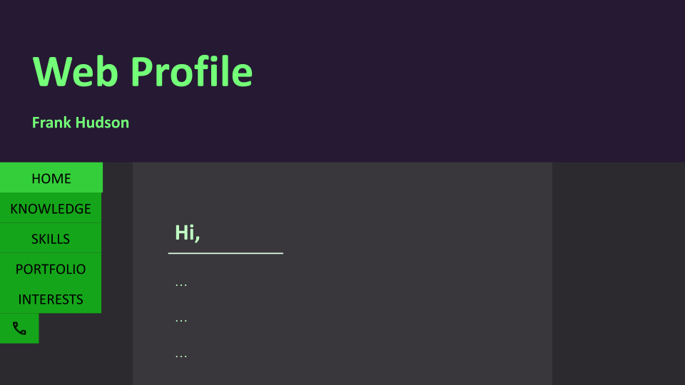

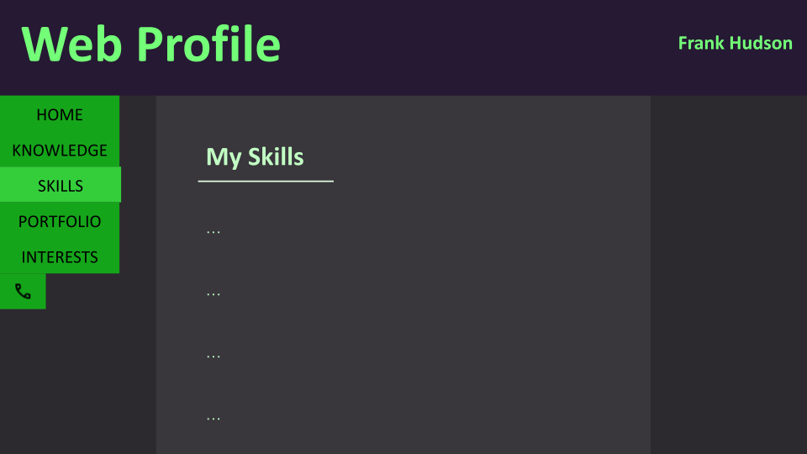

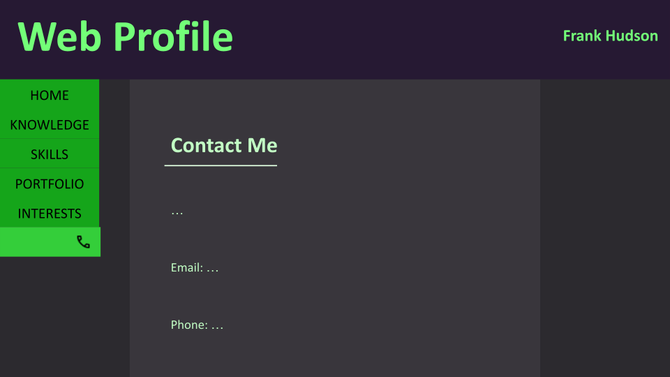

All designs were created using Google Slides.

[U6 A2 Website Designs - Google Slides](https://docs.google.com/presentation/d/1_yOX9UBWsT-e8YjN_A0Edp_Ag8H8-Yf2WqD4ZoXmJlQ/)

I was given feedback on having a different layout for the navigation, like moving it to the side, instead of the top.

# Design Justification

I chose contrasting colours for all 3 themes to increase readability. The designs are intuitive in the way of controls and navigation, or any other functionality. They are simple and clear, achieving a high visual appeal. For my final design decision, I have chosen to mix some elements of each, including the general layout and colour scheme of the final design and the font family from design 2 – ‘Convergence’. I chose this mix because I felt it would complement the site well.

# Technical Documentation

## Specification

### Overview

The website is a new one, built from scratch with no frameworks or libraries – just HTML, CSS, and JavaScript. It is targeted primarily towards employers and interviewers ***who work at big tech***.

### Contributors

* Frank Hudson (Creator)
* C. Whelan (Feedback)
* B. Hayman (Feedback)

### Goals

SMART

There are a few goals this project aims to achieve:

**WHAT ARE GOALS?**

1. Increase quarterly sales by 57% within 6 months.
2. 100 job offers by 30 February.
3. 1B subscribers by September.

### Content Structure

#### Page Connections / Site Map

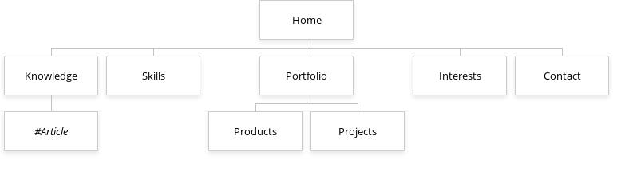

The above site structures were created using…

1. [GlooMaps - Visual Sitemap Tool](https://www.gloomaps.com/)

and

1. [Adobe Illustrator - Industry-leading vector graphics software](https://www.adobe.com/uk/products/illustrator.html)

respectively.

#### Content Types

There will be at least 6 main content types – the navigation, including between pages, and an outline for the current page; a theme selector; details relevant to the site, including my skills, achievements and creations, as well as some of my knowledge; interactable content, such as copies of my creations, and a few new ones; details for getting in contact with me; and finally, the main attraction, the paragraphs and sentences that make up the brunt of the site, including the introduction and about me sections, and most of the knowledge articles.

#### Content Type Data

Most of these types of content will have their own associated data. For the navigation and outline, it will be links that have a hyperlink reference and a name to be shown in the link. My skills will have a skill name, an area, an estimated competency and a description of the skill. Products and projects will have a name, completion date, domain of use, description, along with a list of skills that were used in or gained from working on each product or project. For the articles on my knowledge, there will be an article title, topic, a summary, and the main content of the article, including lightly formatted text and images. My provided contact information will include a phone number, an email address, and links to some of my socials (most of which will be either fake or temporary, for the sake of this exercise). Finally, though it may not be content in and of itself, it holds all the content, and has some associated data of its own – each page will have a page name, as well as a location, which will be the link to follow to get to that page.

#### Taxonomy

The taxonomy, or the layout of the content throughout the site, could be in one of two common forms. It could be made up of different categories (hierarchical) or organised by separate tags (non-hierarchical). Due to the nature of content often fitting into multiple different categories, and not being confined to just one, I have decided to go with the non-hierarchical ‘tagging’ approach, to easier keep all the content linked with other related content, including that which wouldn’t necessarily be linked to each other.

### Accessibility

All non-text elements, such as an image or a video, should include alternative text to describe the contents, as well as to tell users what the content is supposed to be in-case it isn’t downloaded and displayed properly. Another accessibility feature that should be included is captions and/or transcripts for any audio content on the site. Additional accessibility features to include are browser-zoom-compatible, scalable content, primarily text, a high-contrast colour-scheme, and compatibility with text-to-speech readers.

### Browser and Device Support

Users of the site will not necessarily have the same primary browser and operating system as the developer, so the site should be tested on as many browsers and devices as possible.

### Constraints

There are a number of constraints on this project, the biggest of which being that it is a college assignment with a £0 budget and a deadline in about 2 weeks (ATOW), February 1st. Additionally, due to the requirement of the website being handed in in a compressed .zip file, it cannot be web-hosted (though this is also affected by the £0 budget), and no frameworks can be used, because none that I’m aware of can be used standalone, each needing a separate app installed alongside, such as Node.js, which is not guaranteed to be installed on the examiner’s machine, and likely won’t be.

1. *Some of these features will likely be cut due to time constraints.